Hi
Part 2.
Still in Antarctica we got to see two types of penguin. We weren’t meant to get closer than 5m to them but it was ok if they approached us.

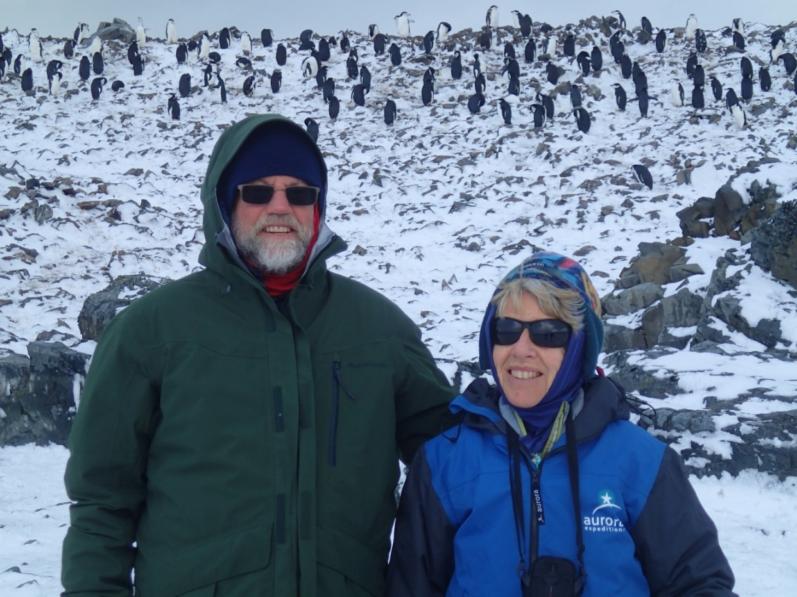
They seemed be constantly on a mission.
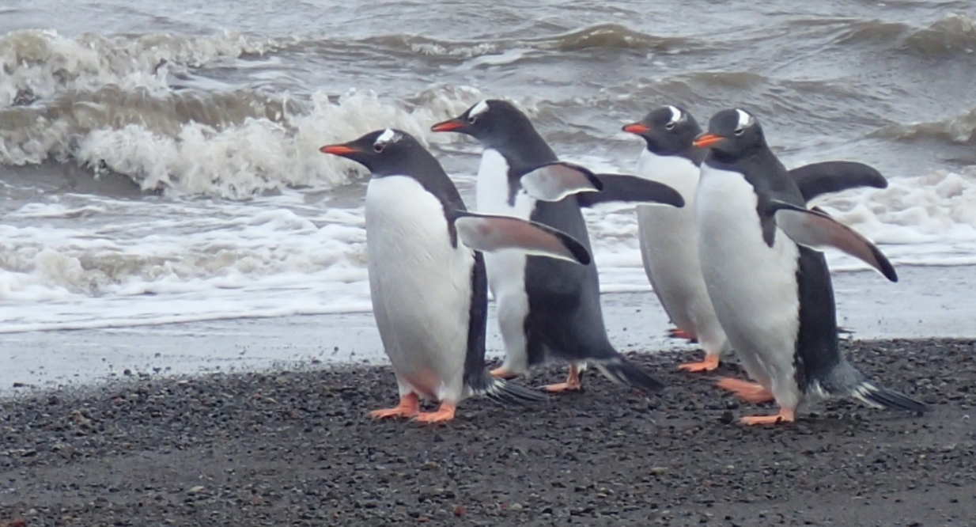
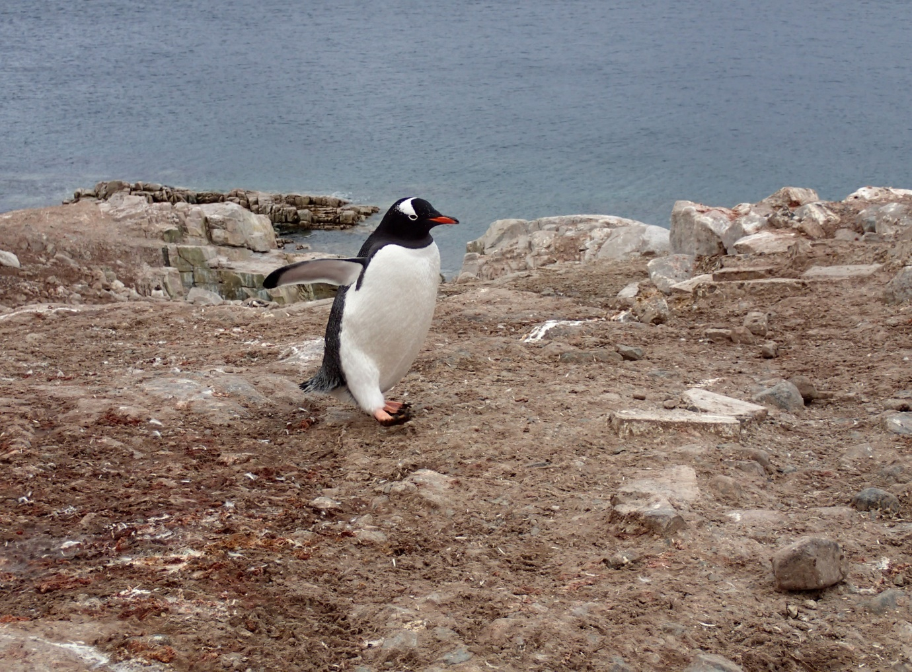

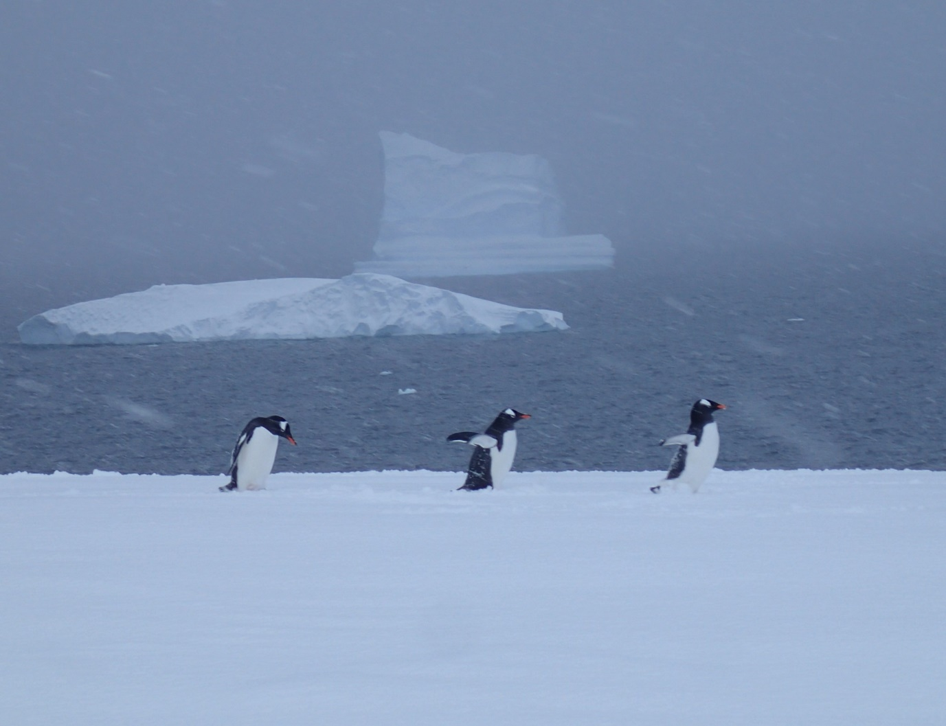
Anyway, after several great days we headed for the Falklands. Unfortunately, this is as close as we got.
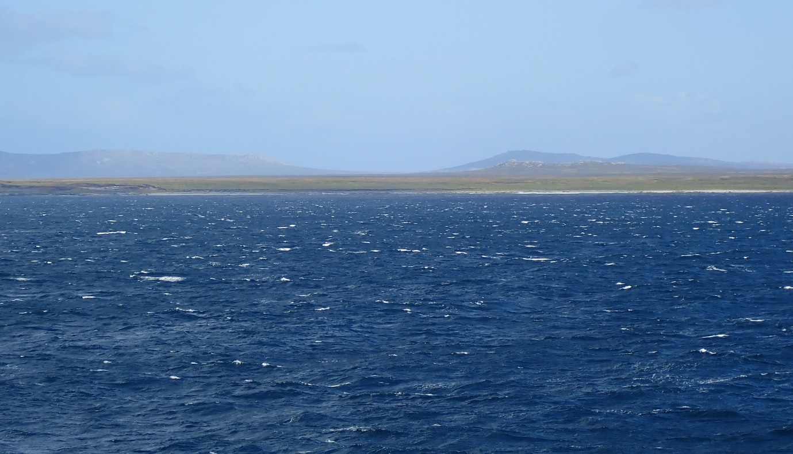
The night before arriving at Port Stanley disaster struck. One of the passengers came down with a fever. It looked like the dreaded covid had arrived. The Falklands wouldn’t have a bar of us. This was the beginning of our real troubles. We went into lock down mode, stuck in our cabins. Temperature taken every day. But it wasn’t all grim. They sent me a birthday cake to celebrate another year.
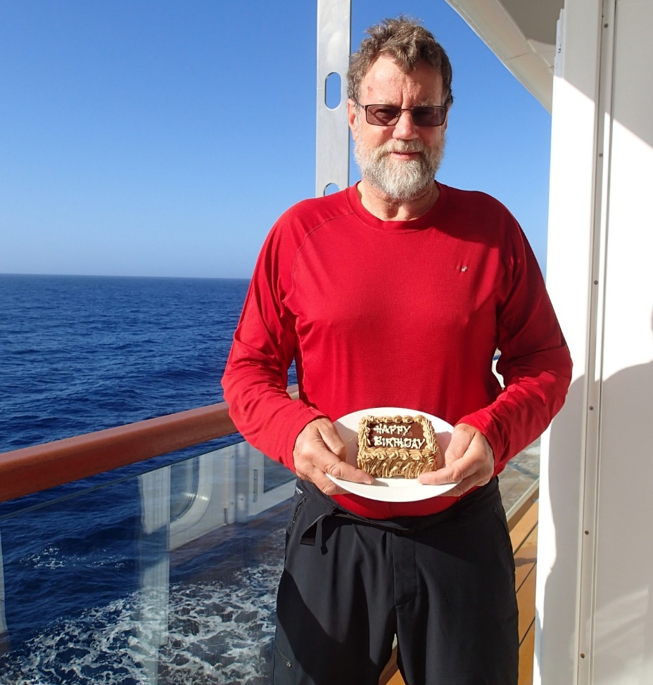
We sailed up the coast to Uruguay. For 14 days we were anchored off Montevideo. The city was tantalisingly close.
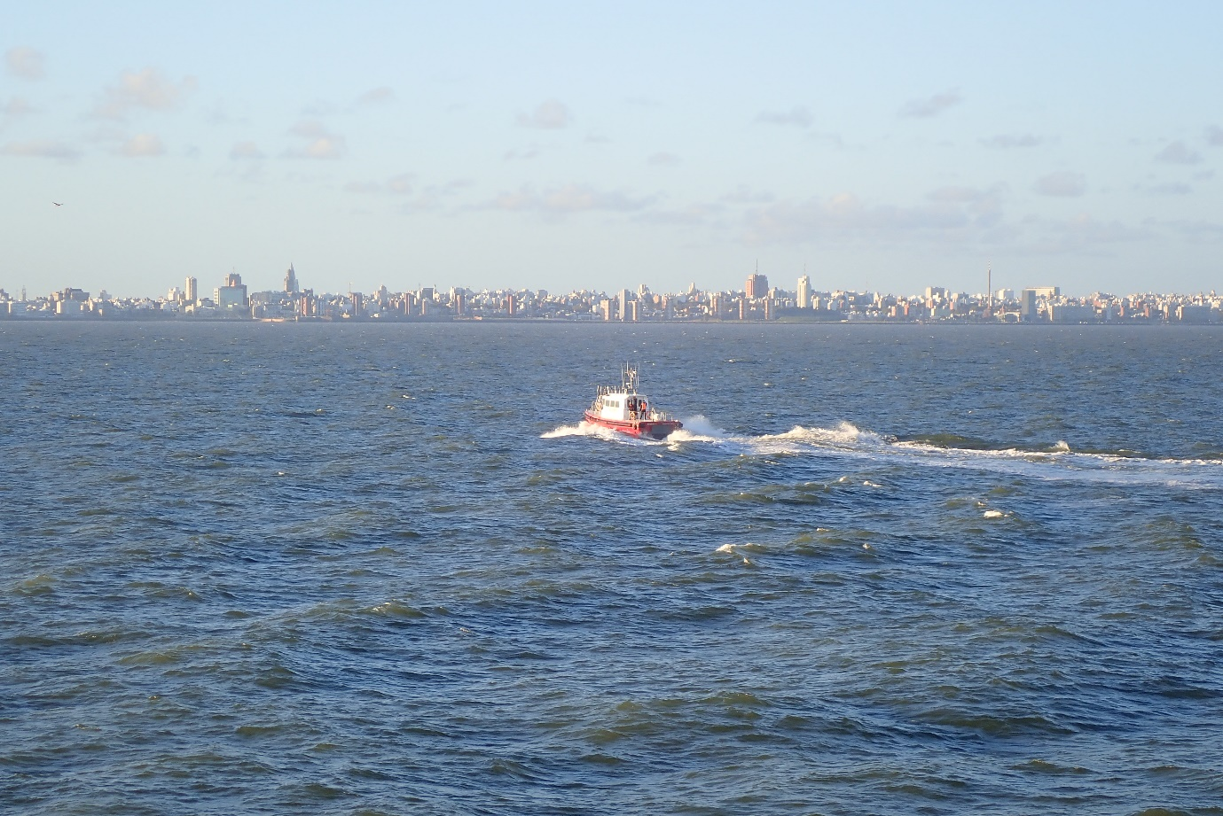
In that time we were stuck in our rooms. We had an outside balcony and 250 lengths of it meant we had walked a kilometre. That got boring. We went through all the movies on our tv. Played cards. Tried to get on the internet but mostly that didn’t work, read the kindle and, in my case was seasick for two days in heavy weather with the ships motion restricted by the anchor.
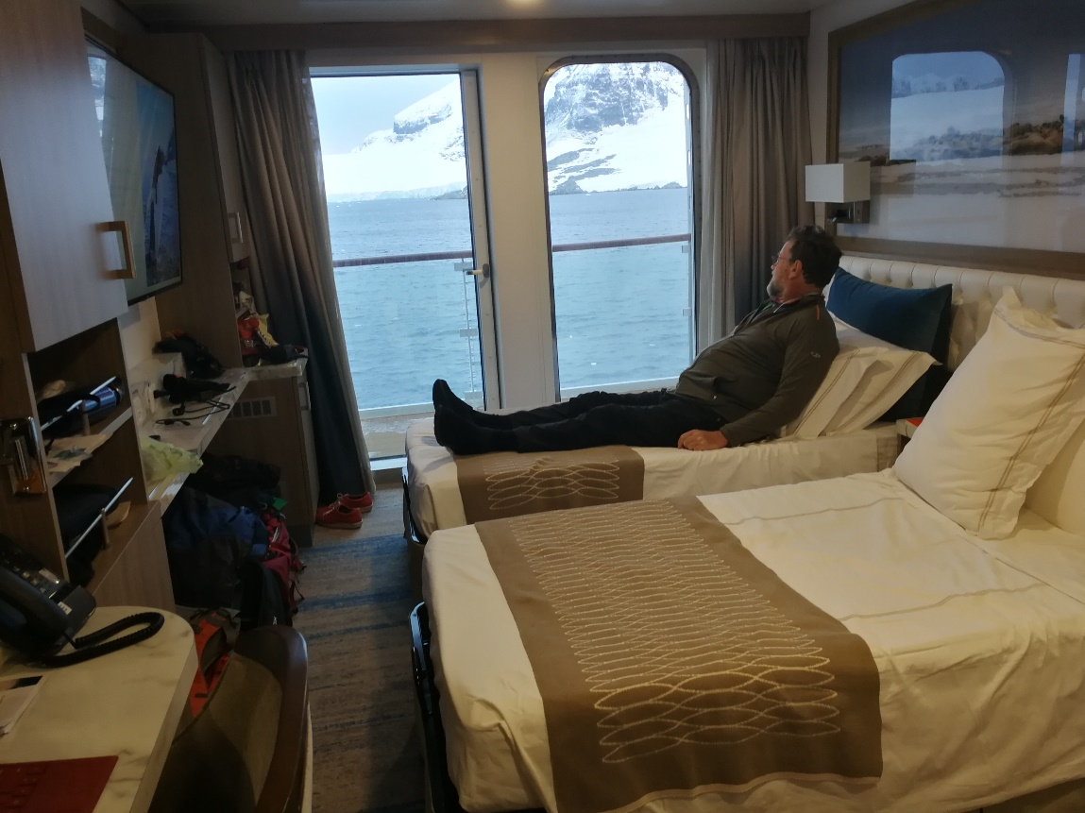
All the time Aurora continued to promise to get us home, but the first problem was to get us off the ship. 8 people were evacuated to hospital. Watching 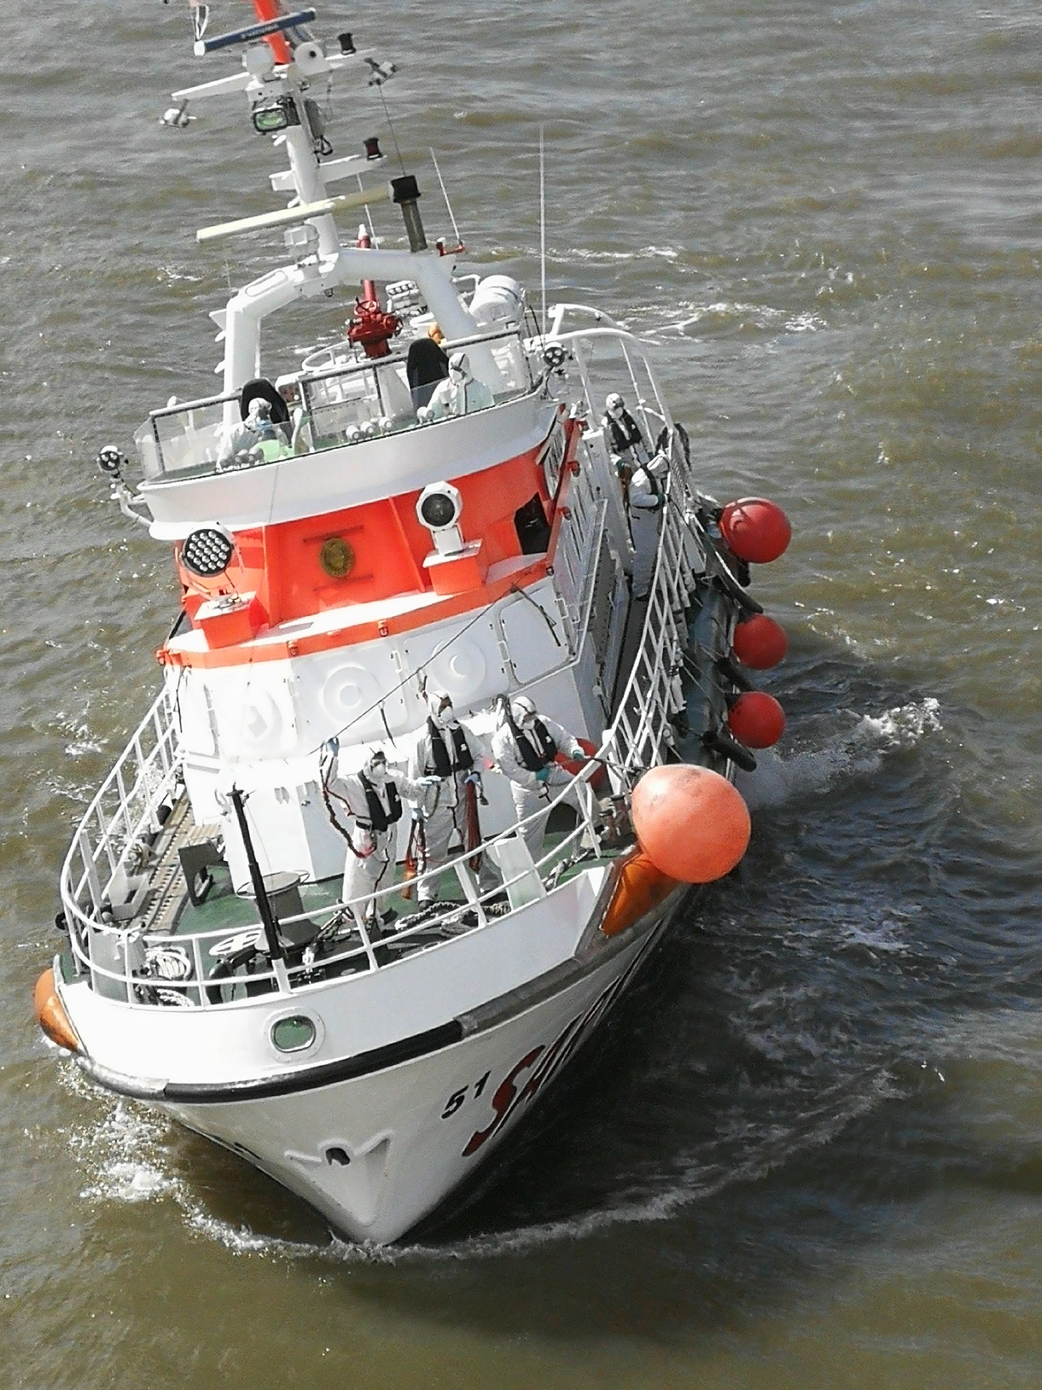
this vessel tie up in the swell to take off sick people was very entertaining and involved lots of shouting. Eventually the Uruguayan officials sent a team on board and we were all tested for Covid.
Linda and I tested positive along with 60% of the ship. We had had no symptoms, so this was a bit surprising but on reflection at least now we don’t have to worry about getting it.
After an awful lot of discussions between countries Aurora agreed to hire a charter flight to get the aussies and kiwis to Australia and Uruguay agreed we could disembark to catch the flight. Australia doesn’t have a good record of allowing kiwis home through Australia so we contacted everyone we could think of to lobby. Suddenly we got an email from a person at MFAT saying she was in charge of getting us home and we were top of their priorities and, and they had agreement in principal with the Aussies. This had us dancing on the balcony.
So, on 12 April we disembarked into 4 buses, two ambulances and escorted by 10 police cars and umpteen police motor bikes we were transported, sirens going to our chartered flight. Along the way many Uruguayans came out to wish us well. They waved Uruguayan flags, we even saw a white banner with a heart in the centre being waved in our direction. They wished us luck, they welcomed us. It was very heart warming to have such encouragement.
Our charter flight was carefully segmented with plastic partitions so that those without covid sat up front, we sat in the middle and the really sick at the back. We eventually arrived at Melbourne airport. The plane was surrounded by masked and gloved people. After some mucking around they let the kiwis off. We were told to follow the cones. Off we went on a ramble, unescorted around the airport, into a building where a chap asked if we were all right and sent us out the other side. 500m of cones later we got to our ride back to Auckland, right next to the jet we had landed on. We were ushered on, no preliminaries. Talk about flash. All organised just for us 13 kiwis by MFAT. How good is that.
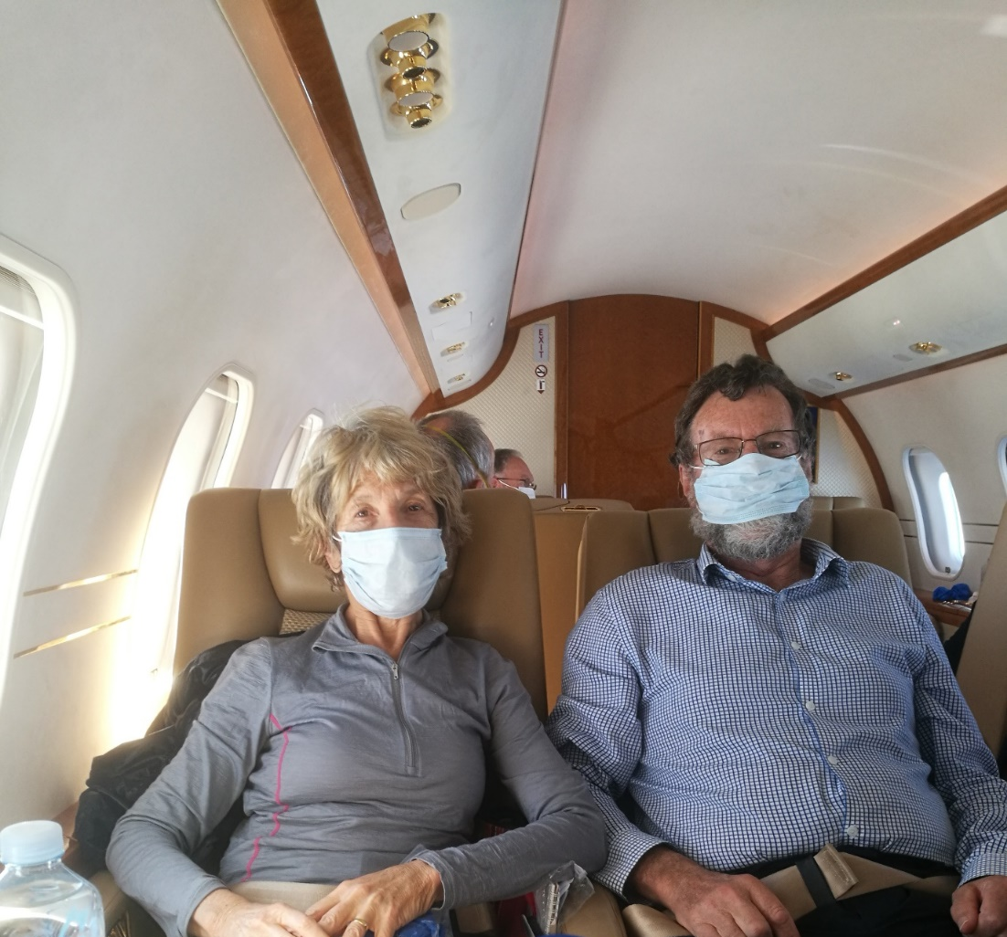

We arrived in Auckland, no formalities, whisked off by bus to our quarantine hotel. We were met by a bunch of MOH people, moved quickly to our room and checked out. All the kiwis receiving us were welcoming, pleasant, smiley, thoughtful and sympathetic. All arrangements were smooth. We are in a spacious room and well looked after.
All this contrasts with our poor Aussie Expedition companions who were treated as pariahs, took 4 hours just to be processed at the airport (by which time we were in our hotel room) and are now placed in an old, dingy, dirty hotel with no natural light or opening windows and small rooms. Man its great to be a kiwi!
Two days ago we were tested again, and, dammit, we are still covid positive. However, we get to exercise twice a day and as you can see I am not sick.
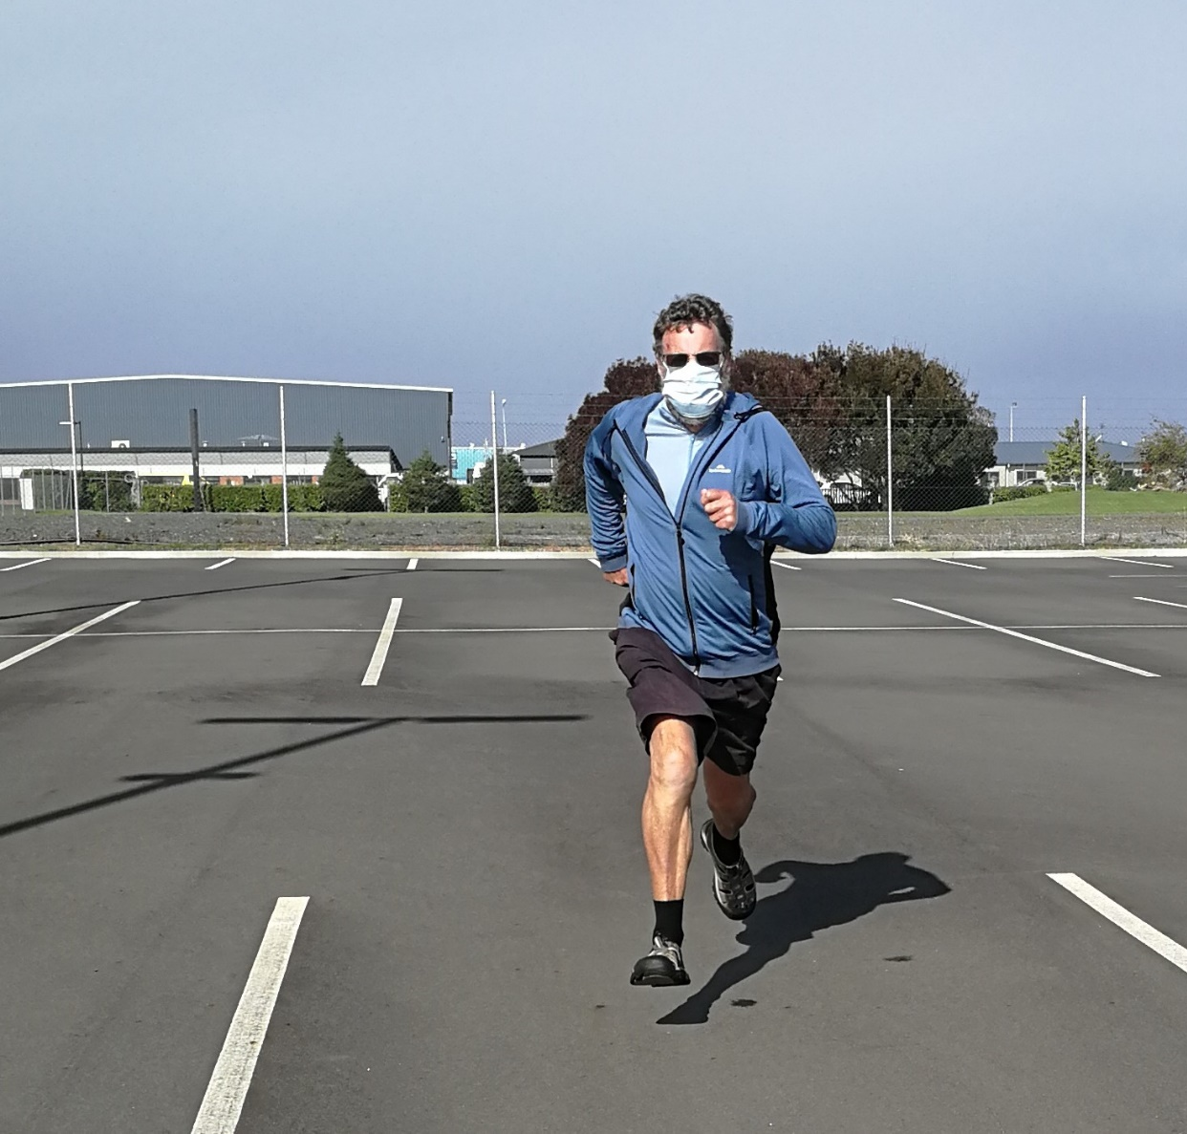

Tonight we were told we can go home after 2.30 on the 26th of April. Now we have a target.
Cheers to you all, healthy, I hope.
Geoff Todd

