HELP: CONTACTS
BEFORE THE CONVOCATION

Chairman of the Organising Committee
Max Currie - Tel (03) 572 4448(h) 027 338 8820(m)

Email us at 2020convo@gmail.com

WHILST AT THE CONVOCATION

General Enquiries David Marsh Tel 02737 66404

Transport Enquiries Day Out – 0274 DAY OUT

OUR CONVOCATION IS SPONSORSED BY
SUPREME GRAND ROYAL ARCH CHAPTER
NEW ZEALAND
1892 | 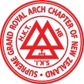 | 2020
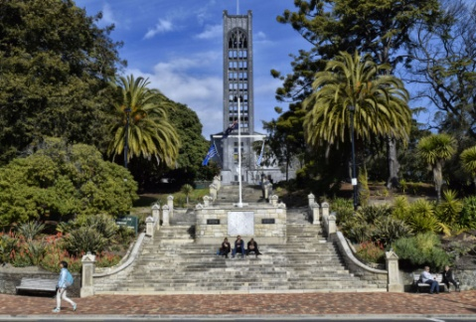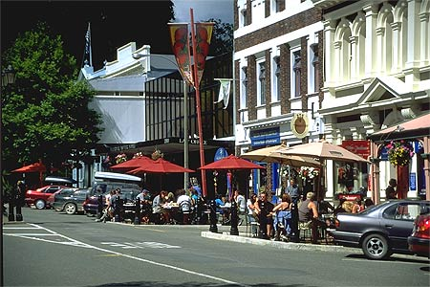
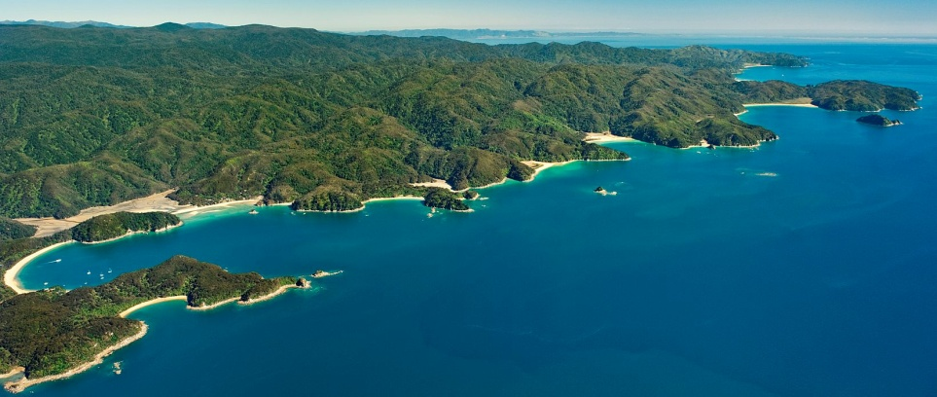

128TH ANNUAL GRAND CONVOCATION

Nelson/Whakatu, New Zealand/Aotearoa

ON 12,13,14,15 MARCH 2020

INVITATION AND REGISTRATION
For the detailed programme download: 2020Prog.pdf
Welcome to the 128th Annual Convocation
Dear Companions
It has been a number of years since the Grand Convocation came to this District and myself and all of the Companions in this District are pleased to welcome you all to our piece of “God’s Own”. The Convocation will be held at two venues. The Installation Ceremony will be at the recently rebuilt Nelson College of Musical Arts (Nelson School of Music) and the rest of the events at the Grand Mercure Hotel located in the area of Nelson known as Monaco.
The hotel and its accommodation are modelled on an old English village and the recently updated accommodation is available in a number of formats to suit your need.
The city of Nelson is a short drive from the hotel and its many cafes and other attractions are here for you to enjoy as well as the internationally famous Abel Tasman National Park. This is a convocation venue at which you should seriously consider extending your stay to see the delights of the scenery and fine wines and beer available all within a short drive of you hotel.
The Installation committee has prepared a series of useful guides to the area and also some suggested tours. I would like to express our gratitude to the Heartland Bank for its sponsorship of the wine at this event. I wish you all a marvellous time in this beautiful part of the South Island.
Max Currie
Grand Superintendent Nelson/Marlborough/Westland District

Page1
USE YOUR LHS MOUSE BUTTON - DOUBLE CLICK ON THE PICTURE BELOW I THEN OPEN AS NEW DOCUMENT (LOOK IN THE BOTTOM ROW OF YOUR SCREEN FOR A FLASHING THEN STEADY RED SYMBOL. USE YOUR LHS MOUSE BUTTON CLICK ON THIS ONCE AND IT WILL THEN OPEN AS A PDF DOCUMENT).

STEP FOUR - PAY FOR YOUR CONVOCATION

Your payment may be by NZ Bank Cheque (made out to Convocation 2020) and send it to Convocation Registrar at the address below).OR via Bank Transfer Payment to account Name Convocation 2020 Number 02-0704-0055173-003. Please use your surname as the Particulars and convo2020 as the Reference. Please ensure that your payment details (either by Bank Transfer Payment or Cheque) clearly identifies you as the payer.

The 2020 Convocation Registrar, 1 Springlea Heights, Atawhai, Nelson 7010

OVERSEAS VISITORS
Please ensure that the payment into the account ,or any Bank Cheques you send are the required amount in New Zealand Dollars, clear of any transfer and exchange charges. (Payment in NZD Cash on arrival at the registration desk at the hotel at the venue can be accepted.)

PAYMENT OPTIONS FOR THE CONVOCATION
Please place a tick beside your selected payment option
My NZ Bank Cheque accompanies this registration. | $
I have paid by Bank Transfer to account 02-0704-0055173-003 with my surname as Particulars and convo2020 as the Reference. | $515.00
Overseas Visitors only - I wish to pay in NZD cash upon arrival at the Convocation Reception Desk. | $

STEP FIVE - PROVIDE FURTHER INFORMATION

TRANSPORT REQUIREMENTS
If you require transport on arrival and departure please provide the information below.
Arriving By | Air/Coach | Departing By | Air/ Coach
Arrival Time | 16.45 | Departing Date | 18 March
Arrival Date | 12 March | Departing Time | 09.45
Flight/Service | ANZ 123 | Flight/Service | ANZ 345
No of Persons | 2 | No of Persons | 2

For contact purposes during the convocation please indicate where you will be staying and contact details.
Grand Mercure Nelson Monaco. Yes
Privately or hotel/motel. Please provide name and address and phone number.
Page 5
STEP I BOOK YOUR ACCOMMODATION

You must arrange and pay for your accommodation yourself. The recommended accommodation is:

Grand Mercure Nelson Monaco
6 Point Road
www.monacoresort.co.nz
email: groups@monacoresort.co.nz Telephone +64 03 547 8233

36 Rooms have been reserved (allocated on a first come/first served basis.). Quote 66563 to get these great rates
HOTEL Booking must be completed by 10th Jan 2020.

Accommodation Options
For details of the hotel and its facilities find the Hotel Picture the end of this booklet; then click on the picture and it will open as a new document.)

Two bedroom Apartments ( Some have 2 ensuites) | 15 Rooms $220 per night. Per 4 person cottage
Sea View Hotel Room | 11 Rooms $140 per night
Cosy Hotel View Hotel Room | 3 Rooms $140 per night
Summer house Cottage | 6 Rooms $190 per night
Garden Suite | 1 Room $160 per night
All rates above include GST

These rates are available for the entire duration of your stay. For those arriving by car, there is excellent onsite parking at the Grand Mercure Monaco Apartment Hotel. For those who do not wish to stay at the Hotel there are several motels available in the area. The Hotel has set up arrangements at two of these – please ask the Hotel for details.

Transport to the Hotel
If you require transport from Nelson Airport, on Thursday12th or Friday 13th we will be able to transport you to the hotel by Mini Bus. Report to our reception point at the airport between 8.00am and 5.00pm. (Outside of these times you will need to organise a shuttle from the airport to the Hotel either prior to your arrival or at the exit from the arrivals hall.)

Page 2
STEP 2 - CHOOSE THE EVENTS YOU WISH TO ATTEND
Convocation 2020 – Programme –
For more/full details download the file 2020Prog.pdf
Day/Date | Meeting | Start | Finish | Location
Thursday 12 March | Management Council | 9:00am | 12 noon | Grand Mercure - Village Hall
 |  | Lunch | Afternoon | Grand Mercure Village Hall
 | Grand Superintendents  including new G Supts | 2.00pm | 5:00pm | Grand Mercure Village Hall
 | Knight Templar  Re-enactment | 8.00pm | 10.00pm | Grand Mercure Tent City
Friday 13 March | Knights Templar Muster | 10.30am | 12 noon | Grand Mercure Tent City
 | Royal Arch Forum  and Research Chapter | 1.00pm | 4.00pm | Grand Mercure Village Hall
 | #Silver Trowel | 3.00pm | 4.40pm | Grand Mercure Tent City
 | Convocation Meet 'n' Greet | 5.30pm & 6.00pm | 8.30pm | Grand Mercure Village Hall
Saturday 14 March | Ladies' Tour  (Includes lunch) | 9.00am | 12:45pm | Nelson Area Tour
 | Business Session | 9.00am | 11.00am | Grand Mercure Village Hall
 | *Installation Rehearsal | 11.15am | 12.30pm | Nelson Centre of Musical Arts
 | *Convocation Ceremony  (Proclamation) | 3.00pm | 4.30pm | Nelson Centre of Musical Arts
 | Banquet | 7.00pm | 11.30pm | Grand Mercure Tent City
Sunday 15 March | Nelson and Environs’ Tour | 10.00am | 12.00pm
*Coach Transport to and from the Venue is provided
# For details of this event please contact Robert Jaray at robertsjaray@gmail.com.

Dress Codes
Knight Templar Re-enactment Smart casual
Royal Arch Forum Smart casual, Lounge Suit
Meet and Greet Smart casual, Lounge Suit
Business session Smart Casual, Lounge Suit – No regalia
Convocation Ceremony Formal with Regalia for men– Minimum Lounge Suit
All ladies and guests are invited to attend the Convocation Ceremony
Banquet Formal, Black Tie
Page 3
STEP 3 - COMPLETE YOUR REGISTRATION FORM AND EITHER SEND IT OR EMAIL IT TO US
(Download the file called Registration Form from the website)

NOTE CLOSING DATE FOR REGISTRATION IS FRIDAY 21st FEBRUARY 2020

EXAMPLES OF COMPLETED REGISTRATION FORMS

Surname | Marshall |  |  |  | Given names | Steven Theodore
 |  |  |  |  | Preferred Name | Steve
Accompanied by Surname |  |  | Marshall |  | Preferred Name | Ronnie
Home Address |  | 27 Acadia Road
 |  | Richmond
 |  | Nelson
Email address |  | Steviewonder@gmail.com
Chapter Name and Number |  |  |  | Golden Bay 2020 |  | Highest Rank PZ

DELEGATIONS (Overseas and other orders)
Name of Order  Rank | Tasman Bay amalgamated Freemasons  Grand Treasurer

EVENTS REQUIRING BOOKINGS AND PAYMENT
 | Registration#  HRA members  Only# | Knights Templar Enactment | *Meet & Greet | Ladies Tour | Banquet * | Sunday Coach Tour
Cost | $70 | $30 | $35 | $45 | $80 | $20
Total Number of  attendees | 1 | 2 | 2 | 1 | 2 | 2
Total | $70 | $60 | $70 | $45 | $160 | $40

# Registration fee applies only to the registered HRA attendee. HRA Companions and all Freemasons and families are welcome to attend the social events.

*Please specify any special Dietary requirements below
 | Vegetarian | Gluten Free | Diabetic | Other
Special Dietary Requirements:  Banquet and meet and greet | 1

Page 4
CONVOCATION 2020 REGISTRATION FORM
PLEASE COMPLETE AND EMAIL TO 2020convo@gmail.com
OR POST TO
The 2020 Convocation Registrar
1 Springlea Heights, Atawhai, Nelson 7010
Surname |  |  |  |  | Given names
 |  |  |  |  | Preferred Name
Accompanied by Surname |  |  |  |  | Preferred Name
Home Address
Email address
Chapter Name and Number |  |  |  |  |  | Highest Rank

DELEGATIONS (Overseas and other orders)
Name of Order

Rank
EVENTS REQUIRING BOOKINGS AND PAYMENT
 | Registration  HRA members  Only# | Knights Templar Enactment | *Meet & Greet | Ladies Tour | Banquet * | Sunday Coach Tour
Cost | $70 | $30 | $35 | $45 | $80 | $20
Total Number of
attendees
Total

# Registration fee applies only to the registered HRA attendee. HRA Companions and all Freemasons and families are welcome to attend the social events.

*Please specify any special Dietary requirements below
 | Vegetarian | Gluten Free | Diabetic | Other
Special Dietary Requirements:
Banquet and meet and greet

Payment

PAYMENT OPTIONS FOR THE CONVOCATION
Please place a tick beside your selected payment option
My NZ Bank Cheque accompanies this registration. | $
I have paid by Bank Transfer to account 02-0704-0055173-003 with my surname as Particulars and convo2020 as the Reference.
Overseas Visitors only - I wish to pay in NZD cash upon arrival at the Convocation Reception Desk. | $

STEP FIVE - PROVIDE FURTHER INFORMATION

TRANSPORT REQUIREMENTS
If you require transport on arrival and departure please provide the information below.
Arriving By | Air/Coach | Departing By | Air/ Coach
Arrival Time |  | Departing Date
Arrival Date |  | Departing Time
Flight/Service |  | Flight/Service
No of Persons |  | No of Persons

For contact purposes during the convocation please indicate where you will be staying and contact details.
Grand Mercure Nelson Monaco.

Privately or hotel/motel. Please provide name and address and phone number.

Any other relevant information you wish to provide to the convocation organisers

