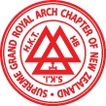 | Supreme Grand Royal Arch Chapter of New Zealand  Grand Lodge of Mark Master Masons of New Zealand  Grand Council of Cryptic Masonry of New Zealand
17 March 2020

Companions,

Due to the Covid-19 virus; the restrictions introduced by the New Zealand Government; and the nature of membership within our Order, Management Council has agreed to strongly recommend to all Royal Arch Chapters and Cryptic Councils that all meetings, including installations and social events, should be suspended until 31 May and a blanket dispensation is hereby given to Chapters and Councils to defer meetings until after this date.

We are unaware of any exposure of our Companions to coronavirus, but it is necessary for us to be proactive for the welfare of our companions. Many of our members are older or have underlying health issues; both considerations make them especially vulnerable to this virus. All decisions must have the welfare of our companions as their primary concern

We must recognise the seriousness of the current health situation in New Zealand as well as around the world and should fully acknowledge that each of us should take proper precautions that have been placed upon us to protect others as well as ourselves from contracting the Corona Virus.

Certain administrative functions will still need to be performed – such votes as are required for chapters and councils to operate may be taken by email and suitably recorded for later ratification when chapters can again meet in safety

Finally companions, keep in contact with your companions, especially those who you may not see regularly or those without close family support. Make sure they are well; if they are not, make sure that have everything they need. If you can help, help. This is the time to practice the basic tenet of our order – to take care of our Companions.

I will keep you informed on developments as and when they arise.

Yours fraternally
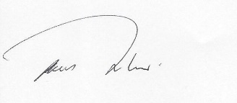
Graham Redman
First Grand Principal.

