Dear Bros
I have just had 18 days stuck in a ships cabin, been diagnosed as having covid19 or Posso as the Australians say and am now in another 14 days of quarantine in Auckland. There is a tale behind this and inspired by the JD epistles I will now tell it over two emails. If nothing else it whiles away time for me the writer and you the reader.
At the beginning of March, when the world was still operating, Linda and I , together with two friends headed off to the bottom of Argentina in order to catch an expedition ship to Antarctica and have an adventure. You can see in the picture 4 healthy types with Ushuaia and the Beagle channel behind. Incidentally the land on the other side of the channel is Chile.
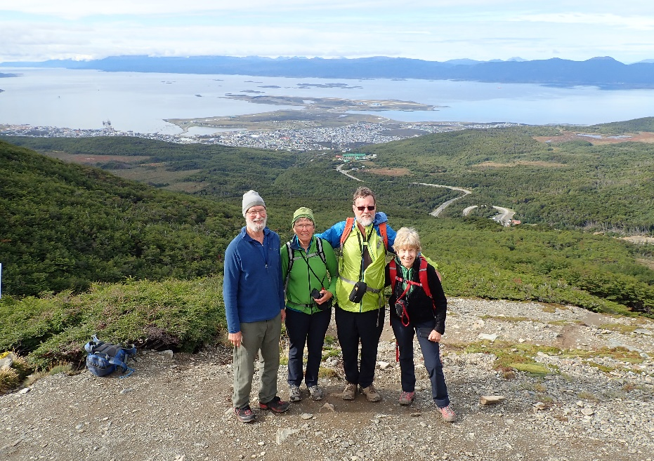
Ushuaia is south of Magellan Straits and the last city before Cape Horn. Young people still drive there all the way down Argentina in combi vans – perhaps we aren’t so old
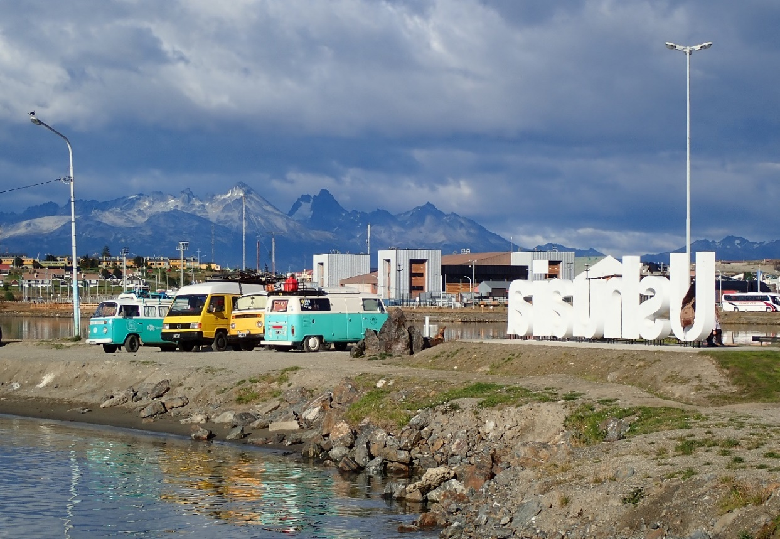

We took a trip on the train to the end of the world.

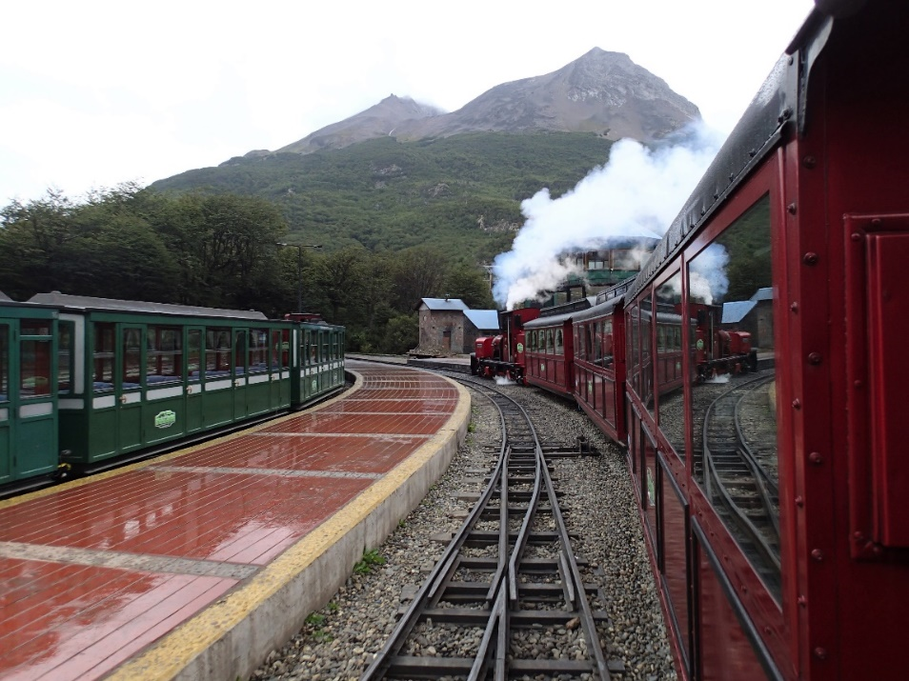
I think this was possibly the beginning of our covid story. We caught the train with a pile of passengers off a large cruise ship. That ship is currently stuck in the Caribbean, riddled with covid. Anyway on the day there was only one case in Argentina and none in Ushuaia so we weren’t leary enough. That cruise ship was the probable source of infection that got onto our ship. Speaking of which, here it is. The magnificent Greg Mortimer, specifically built for polar expeditions. Owned by Aurora 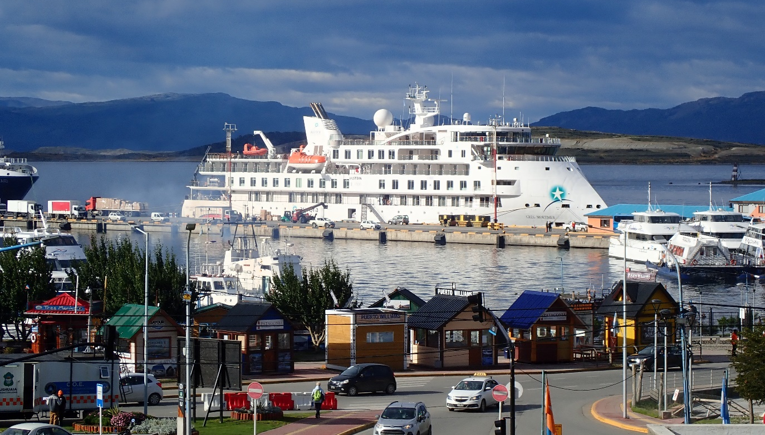our expedition company. There were about 120 expedition passengers. Some like us were to go kayaking, a few climbing and the rest zooming around in zodiacs
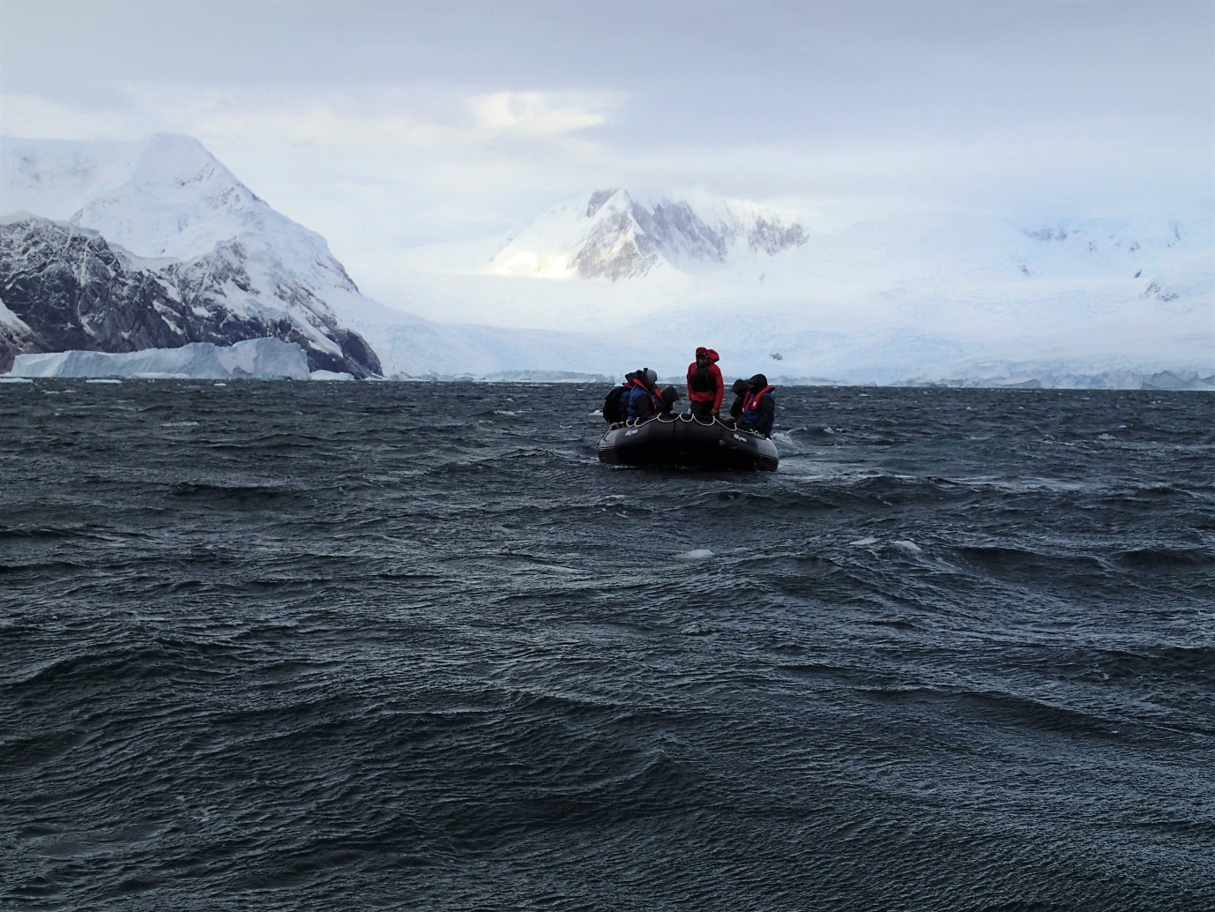

But first we had to cross the dreaded Drake passage. 2 days of up and down although the ship was pretty comfortable. We had no sooner spotted Antarctica on the horizon when we were all called to a meeting. Aurora advised that the world was closing down rapidly and that they felt the cruise needed to be shortened so that we could get home. Aurora undertook to get us all home and to that end had organised a charter out of Port Stanley, the Falklands in 8 days’ time. So, we could have 5 days adventuring then we would have to head back north to take us home.
What followed was 4 magnificent days as we visited and explored different parts of the Antarctic peninsula.
We got kitted out in dry suits and off we went paddling. What a buzz. We had to keep our distance from ice cliffs and bergs. (A variation on social distancing!) They were very active peeling off great chunks all the time with waves that could swamp us if we got too close. The photo following shows Linda and I paddling amongst the ice.
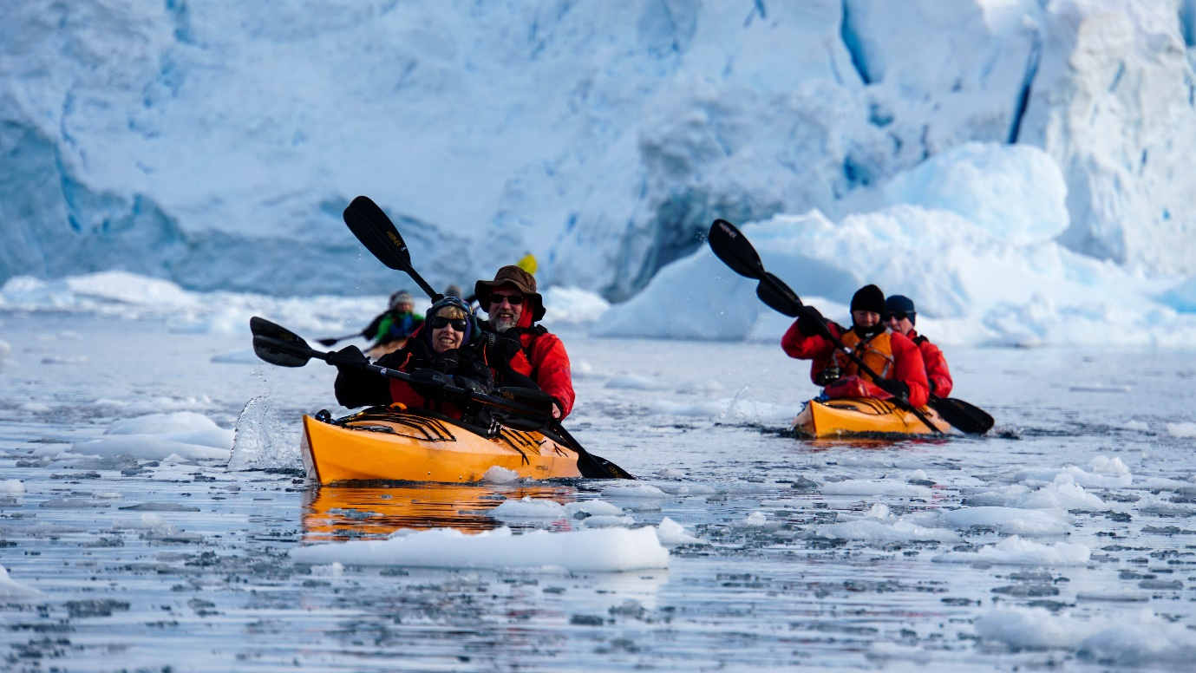
On the first day of paddling the conditions were about as good as you could get.

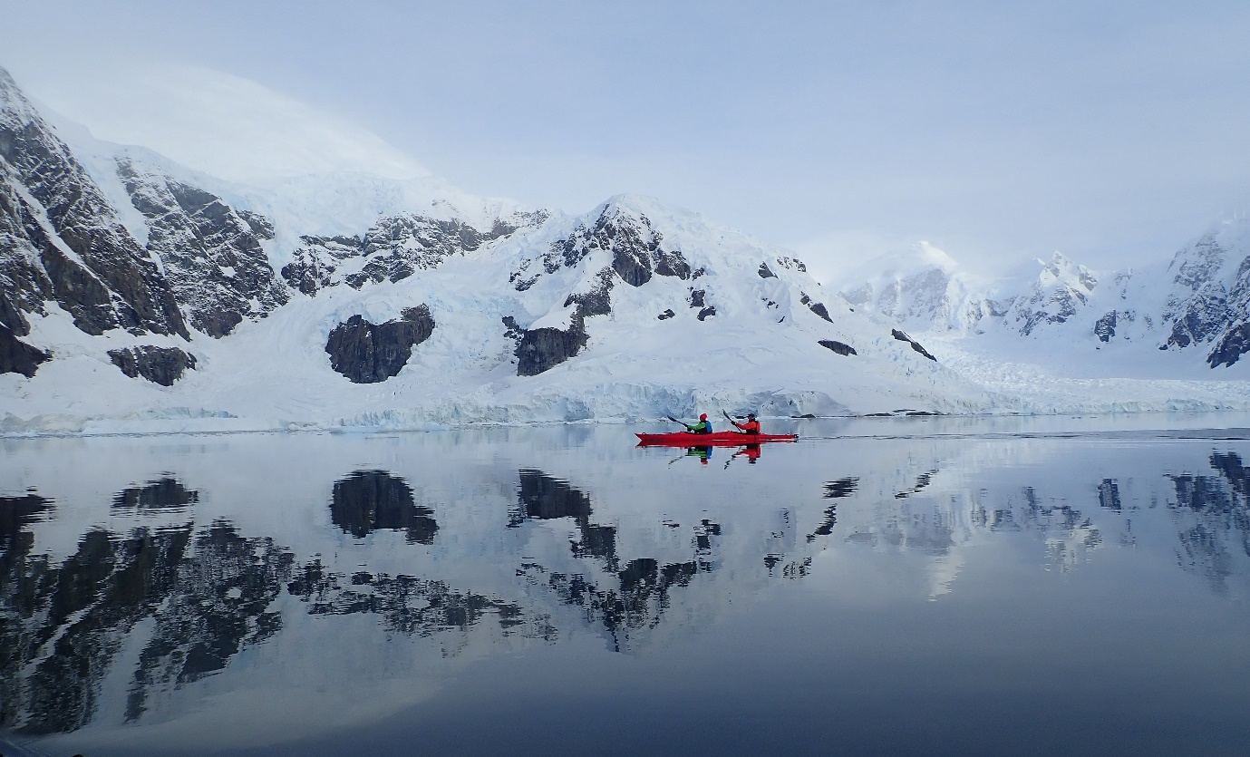
On our second day of kayaking we had a great moment with a pod of humpback whales. They seemed to be as curious about us as we were of them. They circled us for about half an hour. I can tell you that when they blow, the smell is akin to that of a flatulent human

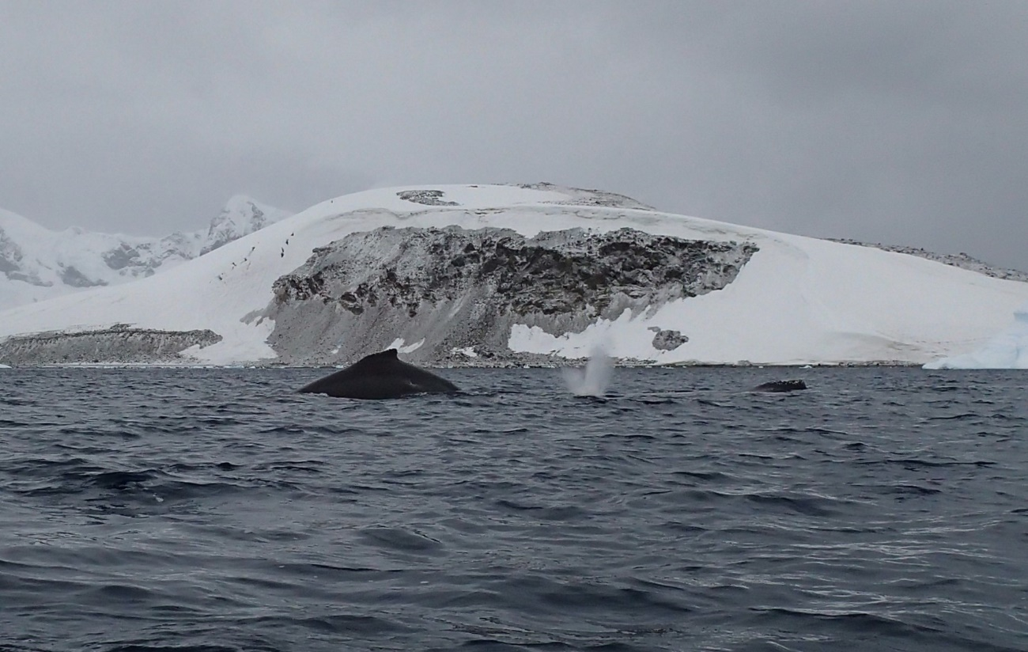

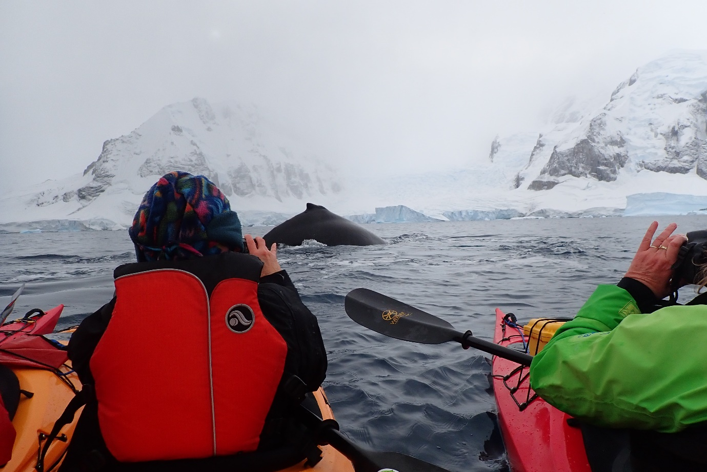In the next photo on the right you can sort of see some penguins zooming through the water. They seem to fly just above the water.
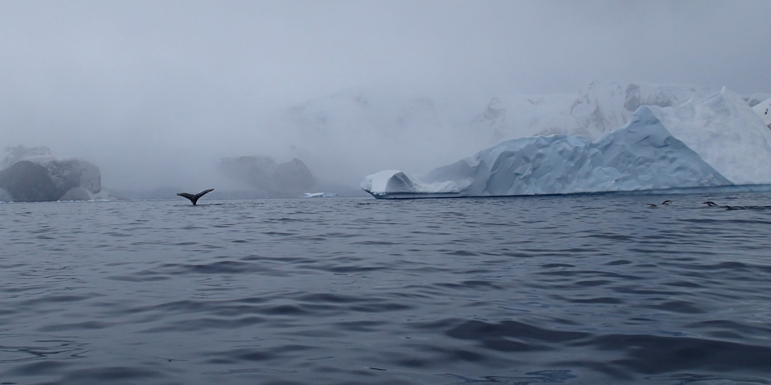

Some of the floes had resident seals sunbathing.
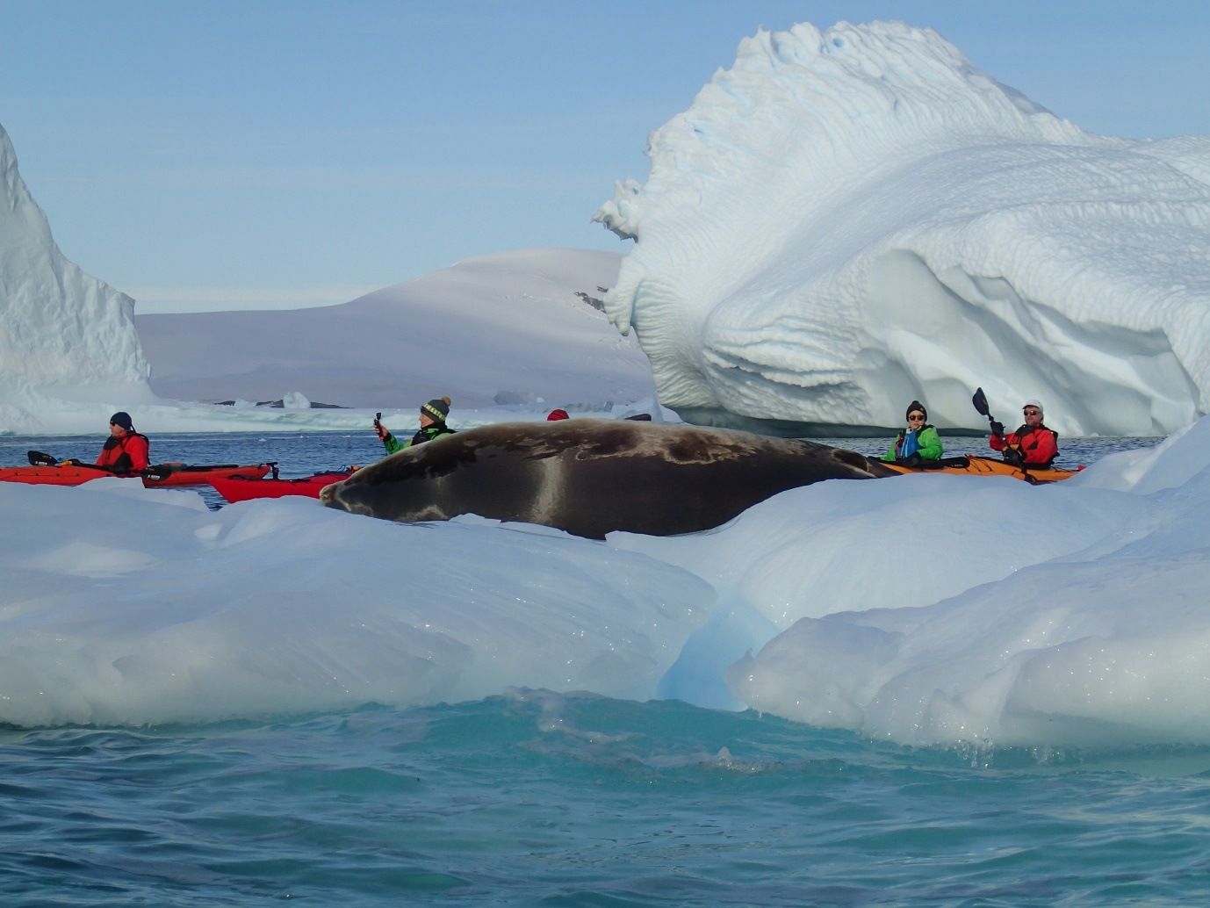
We paddled close to the ice berg below and shortly after it collapsed.
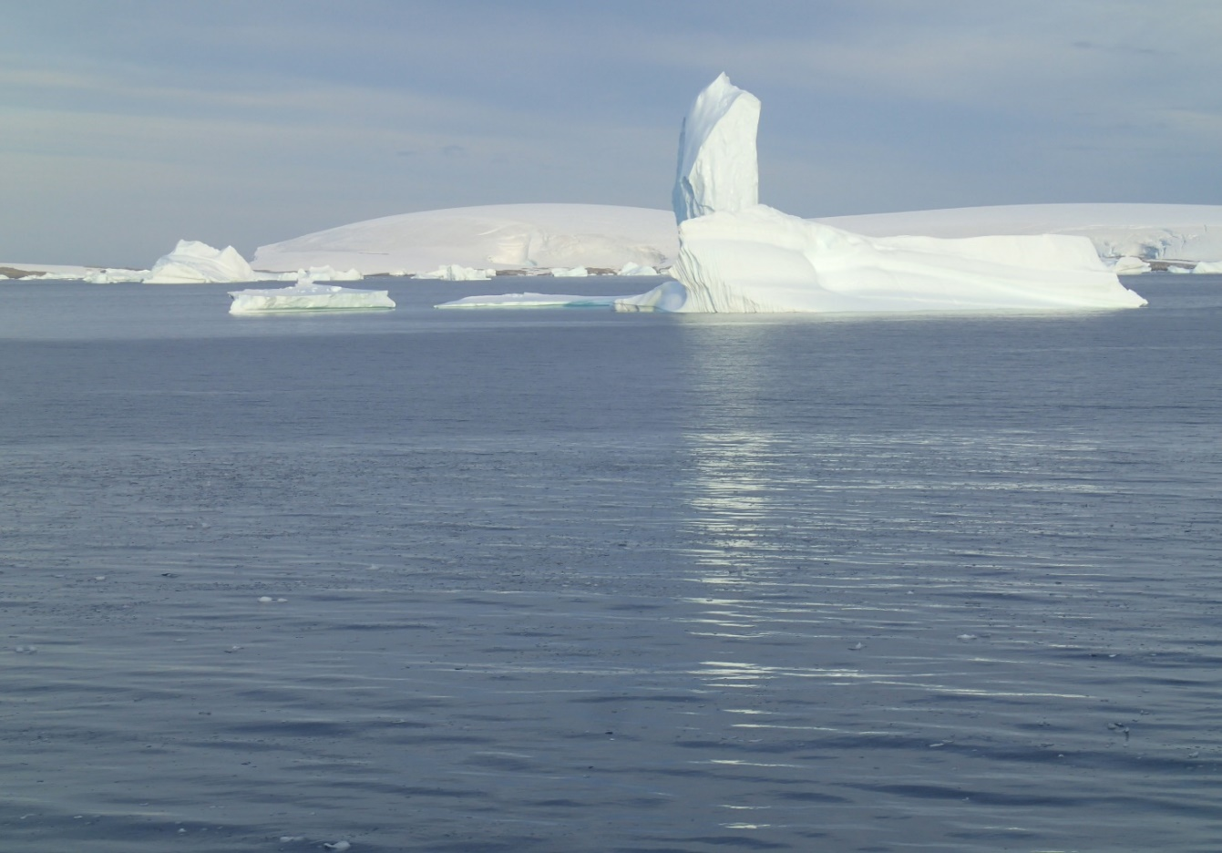

The rest of this saga is in a second email
Geoff

