
SUPREME GRAND ROYAL ARCH CHAPTER OF NEW ZEALAND

JUBILEE MEMORIAL SCHOLARSHIPS

Background

The Supreme Grand Royal Arch Chapter of New Zealand provides for Jubilee Memorial Scholarships to be awarded annually.

The scholarships, which are tenable for one year, are available for technical or vocational training, tertiary or professional education at any tertiary or other educational institution in New Zealand at the discretion of the Scholarship Council which is established under the rules of the Fund.

Scholarships are awarded without regard to Masonic connection, gender, ethnicity, creed, or age.

The Royal Arch Jubilee Memorial Scholarship Fund arose from a desire to mark the 50th anniversary of Grand Chapter in 1942 during the difficult period of the Second World War. Initially it was to support young people to attend either the Papakura Boys Home or the Kirkpatrick Home for Girls in Nelson. Over the years with the demise of both establishments, a move was made towards supporting scholars in their tertiary studies whether at a technical institute or a university. While this has been funded by Chapters making annual donations to it, several individual members left bequests over the years which have augmented the capital base.

Fuller details of the fund are shown in the rules governing it. The Fund is a registered charity (CC 38396).

Criteria
Applicants for awards must:
- have a good academic record having completed or be about to complete secondary school/college and be progressing to tertiary education or training or already be engaged in tertiary education or training
- provide a CV (or similar personal resume)
- be a New Zealand citizen or hold permanent New Zealand residency, and
- demonstrate good citizenship and be involved in some form of community activity supported by a referee's report.

Awards
Awards are made by the Jubilee Memorial Scholarship Council on the information supplied. Late, incomplete, or applications lacking information will not be considered. The Council's decision is final. Except in exceptional circumstances awards will not be given where the applicant is already in employment.

Applications
Completed applications, signed and dated, must be lodged by the applicant with the appropriate District Grand Superintendent by 31 August. Names and contact details of these Grand Superintendents are available from gse@royalarch.org.nz or at https://freemasonsnz.org/sranz/grand-chapter-info/ (refer page 2).

Payment in respect of any scholarship awarded will be made in December each year.

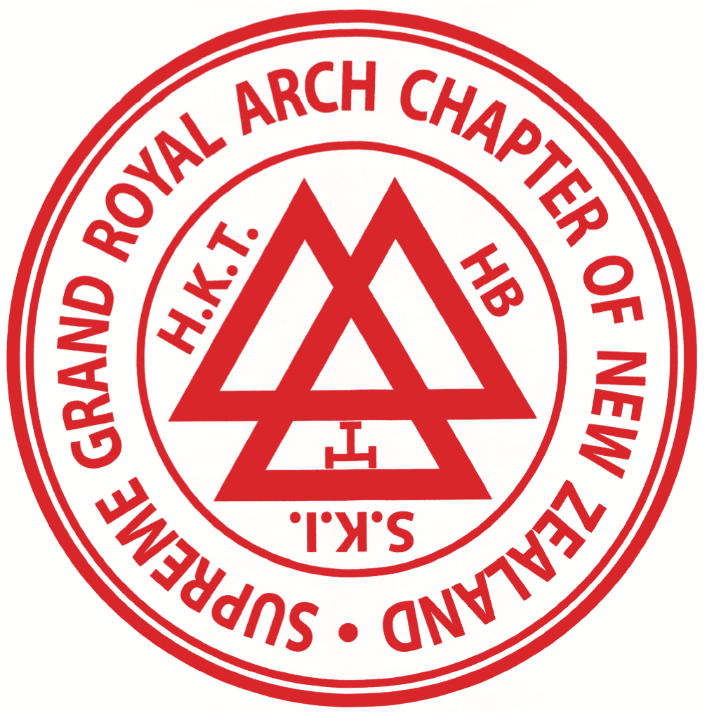
Jubilee Memorial Scholarship Application Form 2025/26
Complete both pages

Personal details Ms Miss Mr Other: ......................

Permanent address

Study address
(if different)
Surname or family name First or given names

Phone:
Mobile:
E-mail:

Study information
Where are you currently studying (2025) and in what year/stage of study?

Where do you intend to study in 2026? For what qualification and in what subject?

Education record
Ensure latest relevant results achieved are attached.
If there is insufficient space below, append attach information on additional pages.

Institution From (date) To (date) Results achieved

Scholarships/awards Name Institution $ value
List or attach details of any scholarships or awards held for the following year and any applied for.

Community involvement
List or attach details of your community work and any awards or other recognition of your voluntary work you have received.

Referee Name, address and contact details - referee's statement must be attached.
Details of referee supplying your enclosed report on community involvement.

Additional Information
Provide any other information which you consider might aid consideration of your application.

A CV or similar personal resume must be attached.

Bank account details Please provide or attach clear details to enable direct crediting of any award made.

A formal presentation of the awards will be made locally as arranged by the relevant Grand Superintendent. Non-attendance may lead to recourse of any grant made.
PRIVACY PROVISIONS
The information requested in this application will be used solely for the purposes of assessing your application. If you are successful, the Supreme Grand Royal Arch Chapter of New Zealand may use your personal information for promotional purposes. Personal information contained in this application will be made available to authorised persons within the Supreme Grand Royal Arch Chapter of New Zealand. The Jubilee Memorial Scholarship Council may need to contact third parties to:
- confirm details of academic results supplied
- verify information relating to community involvement, and/or
- make such other enquiries as to satisfy itself of any matter relating to the application.

DECLARATION
I have read and understood the requirements for an application for a Jubilee Memorial Scholarship and the privacy provisions and, if awarded, I undertake to acknowledge the assistance provided by the Jubilee Memorial Scholarship whenever and wherever appropriate.
Date:
Signature of applicant
Checklist: (Applicant to complete)
Are all details filled in correctly? ☐
Is your referee's statement attached? ☐
Is your CV/resume attached? ☐

