Brand Guidelines
Freemasons New Zealand Special Olympics
National Summer Games Hamilton 2021

Overview
These guidelines are designed to help staff, clubs and lodges of Special Olympics New Zealand and Freemasons New Zealand talk about each organisation and their partnership with the correct language and provide guidance on the appropriate use of the Freemasons New Zealand Special Olympics National Summer Games logo.

Language is important: Using the correct terminology
Freemasons New Zealand Special Olympics National Summer Games Hamilton 2021
The full name of the event is the Freemasons New Zealand Special Olympics National Summer Games
- Use the full title of the event the first time it is written. Afterwards it may be shortened according to context and audience. For example, the Freemasons Special Olympics National Summer Games.
- In all cases where the name is shortened “National Summer Games” may not be changed and should be used as opposed to “Nationals”, “National Championships”, “National Games” or “Summer Special Olympics”.
- After the first time “National Summer Games” is used it may be shortened to the acronym NSG.
- Do not refer to the event as the Freemasons Special Olympics. The event is the National Summer Games organised by the organisation Special Olympics. The naming rights partner is Freemasons New Zealand.
Special Olympics New Zealand
- Refer to participants in Special Olympics as Special Olympics athletes rather than Special Olympians or Special Olympic athletes
  - Correct: Mary is a Special Olympics Athlete
  - Incorrect: Mary is a Special Olympian; Mary is a Special Olympic athlete.
- Do not use the word “The” in front of Special Olympics unless describing a specific Special Olympics event or official.
  - Correct: Special Olympics is organising the National Summer Games; The Special Olympics National Summer Games.
  - Incorrect: The Special Olympics is organising the National Summer Games.
- Refer to individuals, persons or people with intellectual disabilities, rather than intellectually disabled people or the intellectually disabled.
  - Correct: John is an athlete with an intellectual disability.
  - Incorrect: John is an intellectually disabled athlete; the intellectually disabled athlete John.
- Avoid the description “special needs” and instead refer to individuals, persons or people with intellectual disabilities.
- Do not use the adjective ‘unfortunate’ when talking about persons with an intellectual disability. Disabling conditions do not have to be life-defining in a negative way.
Freemasons New Zealand
For the purposes of this sponsorship please refer to the organisation as Freemasons New Zealand.
- Avoid using terminology like ‘The Masons’
When referencing a Freemason individual acceptable terms to use are Freemason e.g. John is a Freemason. While the term Brethren or Brother is a commonly used term in lodges or amongst Freemasons for the public it is preferable to use terms like John is a Freemason
- Avoid John is a Brethren or John is a Brother.

Visual Identity
The story behind our logo
In 2020 SONZ announced a competition for Special Olympics athletes to create a custom logo with Hamilton flair.
After receiving many creative designs and after a hard deliberation process a team of four athletes; Sarah-Jane Hudson, Caitlin Thomas, Sarah Griffin and Deshan Walallavita, won with their logo inspired by the icons of Hamilton, including hot air balloons, the Waikato river and the Fairfield Bridge.
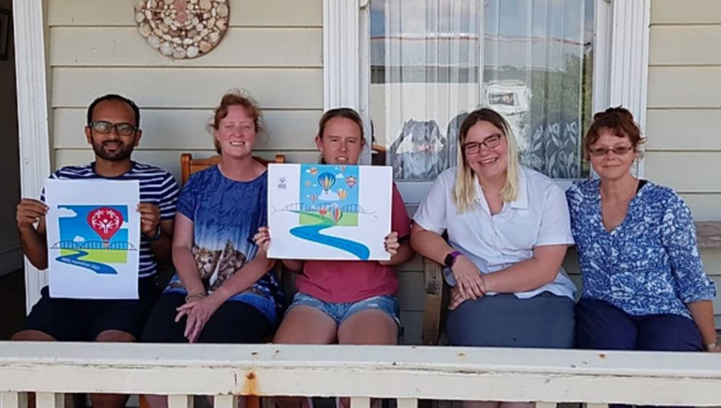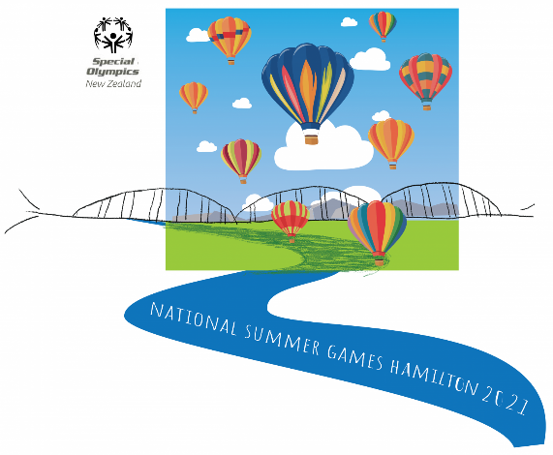
From their design the 2021 Hamilton National Summer Games Logo was formed, and now the logo has grown even more to reflect the partnership between Special Olympics New Zealand and Freemasons New Zealand.

Where to use the logos

Main Logo Portrait and Banner designs
Official Documents and resources | As a poster and banner (Print/digital media)
Letterheads | Email signature (Landscape design)
Merchandise and apparel
On promotional banners, posters and digital media
Social media profiles and on social media

Main logo
The main logo is the key branding of the Freemasons New Zealand Special Olympics National Summer Games.
It is to be used as a primary logo on offical documents and resources, letterheads, merchandise, apparel, social media profiles and social media graphics, on promotional banners, posters and digital media.
Be careful when choosing which background to pair with the logo, and whether or not to use black or white text. Don’t use the logo on a background that is very busy.
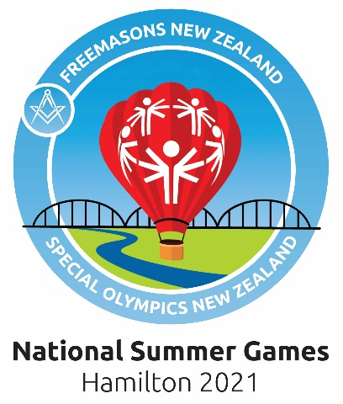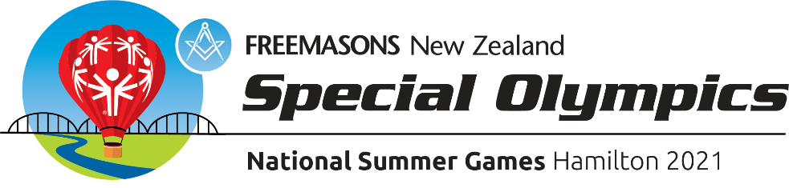

Poster and Banner Design
The poster and banner designs are available for use in promotions and resources.
The poster design can be used as a poster and as additional graphic resource. For instance as a self-contained graphic on digital or print promotions.
The banner design can be used as a banner design on signage, in email signatures and as an additional graphic resource. For instance as a graphic on digital or print promotions.
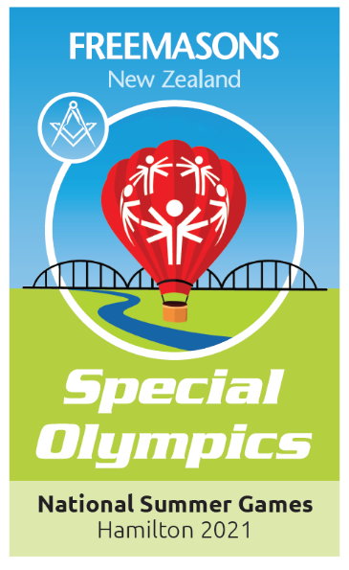
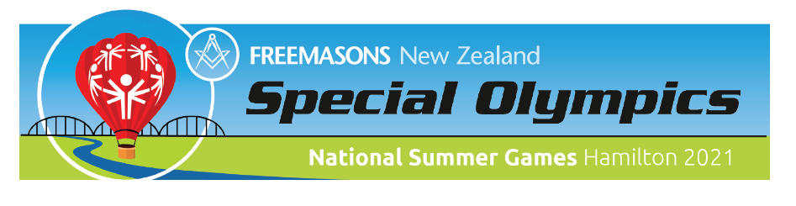

Typography and colour palette
Colour Palette
Primary Colours | Pantone | C/M/Y/K | R/G/B | Hex
SO Red | 186C | 0/100/100/0 | 255/0/0 | #FF0000
Light Green | 382C | 35/0/100/0 | 178/210/53 | #B2D235
Light Blue | Process Blue | 100/20/0/0 | 0/149/218 | #0095DA
Black | Black | 0/0/0/100 | 0/0/0 | #000000
White | - | 0/0/0/0 | 000/000/000 | #FFFFFF

Secondary Colours | Pantone | C/M/Y/K | R/G/B | Hex
Dark Blue | 300C | 100/50/0/15 | 0/99/165 | #0063A5
Dark Red | 1945C | 0/100/100/20 | 196/22/28 | #C4161C

Typography
The preferred font for informational communications is Ubuntu. It is available as a free Mac or PC download at font.ubuntu.com
