BRETHREN ATTENDING GRAND LODGE
PLEASE BRING THIS AGENDA PAPER WITH THEM
FOR USE AT THE COMMUNICATION

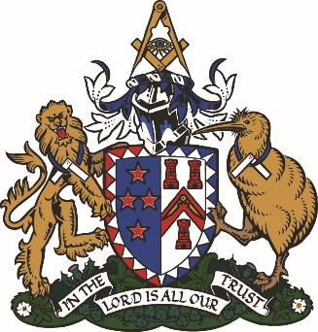
Business to be transacted at the
One Hundred & Twenty Second Communication
and the Grand Installation to be held in
CHRISTCHURCH

On FRIDAY 24th and SATURDAY 26th OCTOBER 2025
Grand Lodge will be opened in the Limes Room, Christchurch Town Hall
on Friday, 24th October, at 2 pm.

- To confirm the Minutes of the 2022 Grand Communication held on 11th November 2022.
- To confirm the Minutes of the 2024 Annual Communication held on 9th November 2024.
- To Elect Officers of Grand Lodge.
- To Consider Recommendations for Honorary Past Grand Rank.
- To Consider and Adopt the Annual Report 2024-2025 of the Board of Directors and
The Freemasons Charity.
- To Consider and Adopt the Annual Financial Reports as of 30th June 2025.
- To Consider Notices of Motion [see link below]
- To Appoint Grand Lodge Trustees/Directors.
- Expulsion from the Craft:
- General Business, by permission of the Grand Master.

GRAND LODGE
Will reassemble the James Hay Theatre, Christchurch Town Hall
on Saturday, 25th October at 1 pm for the

INSTALLATION OF THE GRAND MASTER

Appointment and Investiture of the Deputy Grand Master.
Appointment and Investiture of the Divisional Grand Masters.
Appointment and Investiture of the Senior and Junior Grand Wardens.
Appointment and Investiture of the other appointed Grand Officers.
Investiture of the Elected Grand Officers.
Address by the Most Worshipful Grand Master.
Grand Lodge will be closed.
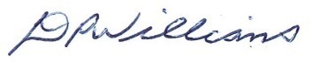

RW Bro Duane Williams PGW
Grand Secretary

All information at https://freemasonsnz.org/2025-grand-installation-and-grand-communication

